**Propeller Calculation**

Total resistance, R=112.6 kN

Effective power, PE = 112.6X10X.5144=579.24 kW

Ship Length, LBP=70.8 m= 232.28 ft

Breadth, B=11.42 m = 37.46 ft

Draft, T=4.4m = 14.44 ft

Speed, V=10 knots

Volume displacement, =2660m3=99652.04 ft3

Propeller diameter, D=.6T=2.6ft

Co-efficient ,DW= =0.429

LCB=0.34M=1.12ft

Taylor wake fraction,

ω t= 0.22

Dt = = 0.149

Thrust Deduction factot, t = 0.204

We know,

T(1-t) = R

T = 141.45 kN

ηH = = 1.02

ηR = 1.04

VA = V(1-ωt )=7.8 knot=4.01 ms-1

Shaft immersion, h= D/2+0.2 = 1.5 m

H= T(Draft)- h

= 2.9m

Thrust ,T =141.45 kN

P0 =Patm+ρgH

=129745 N/m2

PV = 1646N/m2

K=0.2(for single screw)

Z=3

D= 3.08m

Here, $\frac{A_{E}}{A_{0}}=\frac{\left(1.3+0.3Z\right)T}{\left(P_{0}-P_{v}\right)D^{2}}+K$

= 0.5

We know, KT/j2=

= 1.3

From chart,

nm = .5

j=.4

and $\frac{P}{D}=.79$

here, j= $\frac{V_{a}}{nD}$

so, n = 3.85 rps = 231.34 rpm

assume, ηD = .7

PD= = 579.24/.7 = 827.48 kw

Va = 7.7 knots

Bp = 1.158($\frac{n×{P_{D}}^{.5}}{{Va}^{2.5}}$)

= 45.35

δ = 3.28 $\frac{nD}{Va}$

= 252.93

And, P/D = .79

So , From Bp -δ chart we get,

ηo = .52

P/D=.67

**Cavitation Check:**

$$p_{0}-p_{v}=99.6-10.05×shaft immersion$$

$$p_{0}-p_{v}=99.6-10.05×1.5m$$

=83.85 kPa

$$q_{0.7R}=\frac{1}{2}×ρ×{V_{R}}^{2}$$

= $\frac{1}{2}×1.000×({V_{A}}^{2}+{(0.7×π×n×D)}^{2}$

= $\frac{1}{2}×1.000×({4.01}^{2}+{\left(0.7×π×3.85×2.6\right)}^{2}$

=250.33 kPa

$σ_{0.7R}=\frac{p_{0}-p_{v}}{q_{0.7R}}$ = $\frac{83.85}{250.33}$ =0.33

$${\frac{A_{E}}{A_{0}}}_{necessary}=\frac{T}{\frac{π}{4}×D^{2}\left(1.067-0.229\frac{P}{D}\right)\left(0.3{σ_{0.7R}}^{0.5}-0.03\right)q_{0.7R}}$$

= $\frac{141.45}{\frac{π}{4}×{2.6}^{2}(1.067-0.229×0.67)(0.3{×0.33}^{0.5}-0.03)250.33}$

Therefore, $A_{E}$ =0.818 $m^{2}$

Assuming $A_{E}=A_{D}$,

$$A_{E}≈\frac{A_{P}}{1.067-0.229×\frac{P}{D}}$$

$$A_{P}=3.97 m^{2}$$

$τ_{c}=\frac{\frac{T}{A_{P}}}{q_{0.7R}}$ =0.14

From Burrill Cavitation Diagram ($τ_{c} vs σ_{0.7R}$), the value obtained is just below the upper limit for merchant ship propeller.

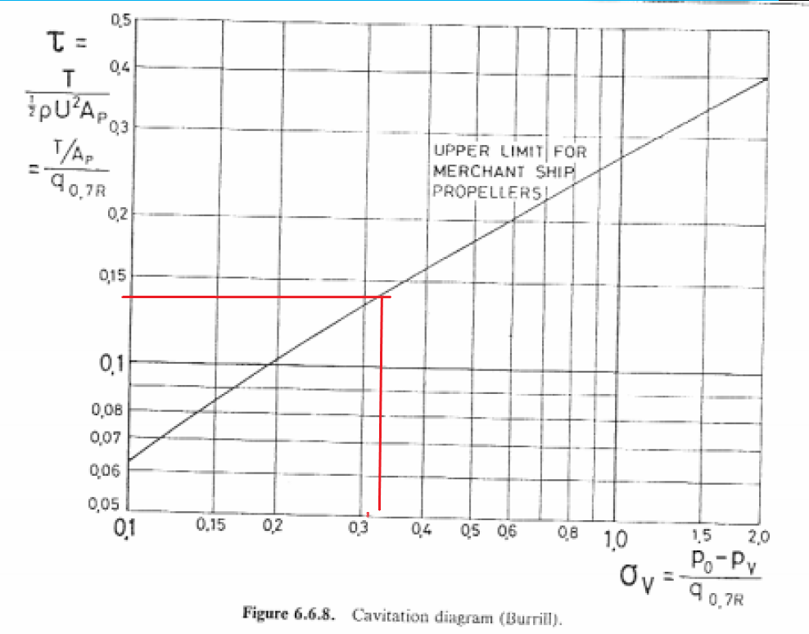

Here,

ηD Calculated = ηH x ηR x ηo

= 0.55

€ = ηDCalculated – ηD assumed

= 0.55 – 0.7 < 0.005

So, ηD = 0.55